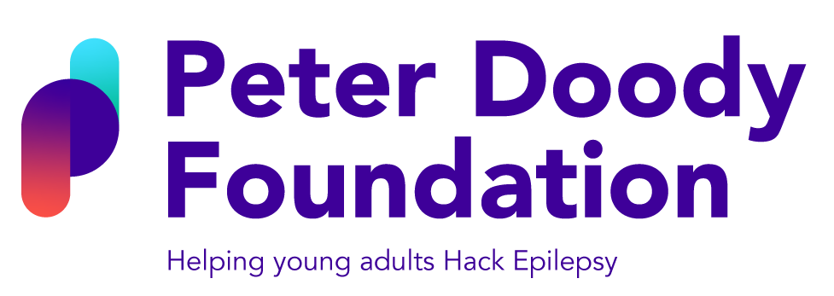
On Saturday the 30th January 2021, I will be part of a team where collectively we will continuously cycle for 21 hours to raise funds for The Peter Doody Foundation to support young adults living with epilepsy and their family, friends and carers. This 21 hour challenge reflects the very tragic reality of the 21 epilepsy related deaths each week in the UK. The Peter Doody Foundation provide life-saving equipment, emotional well-being support and awareness of SUDEP (Sudden Unexpected Death in Epilepsy), but need our continued support to help them in achieving this.
If you would like to find out more about the Foundation please visit www.peterdoodyfoundation.org or visit the social media pages shown above.
Sponsorship and Gift Aid declaration form

Please sponsor me/my team (name of participant/s) _____________________________________________________

To (name of event) 21 HOUR/21 TEAM CYCLE

In aid of (name of charity or CASC) THE PETER DOODY FOUNDATION

If I have ticked the box headed ‘Gift Aid? √’, I confirm that I am a UK Income or Capital Gains taxpayer. I have read this statement and want the charity or Community
Amateur Sports Club (CASC) named above to reclaim tax on the donation detailed below, given on the date shown. I understand that if I pay less Income Tax / or Capital Gains tax in the current tax year than the amount of Gift Aid claimed on all of my donations it is my responsibility to pay any difference. I understand the charity will reclaim 25p of tax on every £1 that I have given.
Remember: You must provide your full name, home address, postcode & ‘✓’ Gift Aid for the charity or CASC to claim tax back on your donation.
Sponsor’s Full Name  (First name & surname) | Sponsor’s Home address  Only needed if are Gift Aiding your donation.  Don’t give your work address if you are Gift Aiding your donation. | Postcode | Donation  Amount  £ | Date paid | Gift  Aid?  ‘✓’
 | Total donations received | £
 | Total Gift Aid donations | £
 | Date donations given to Charity or CASC

